**Programming Fundamentals**

**Lab Report**

**Lab03**



|  |  |
| --- | --- |
| Group Members Name & Reg #: | **Muhammad Haris Irfan**  **(FA18-BCE-090)** |
|  |  |
| Class | Programming Fundamentals CSC103 (**BCE-2B**) |
| Instructor’s Name | Dilshad Sabir |

**In Lab Tasks**

**Question no: 1**

Write a program that prints all even numbers from N to M, where N and M are user input integers?

**Solution:**

In this Program, I took two inputs from the user named N and M, and Printed All the Even Numbers present from N to M, to check the even numbers I used the mod operator here with an if statement, the even numbers are saved in another variable and are printed.

Code and results attached below

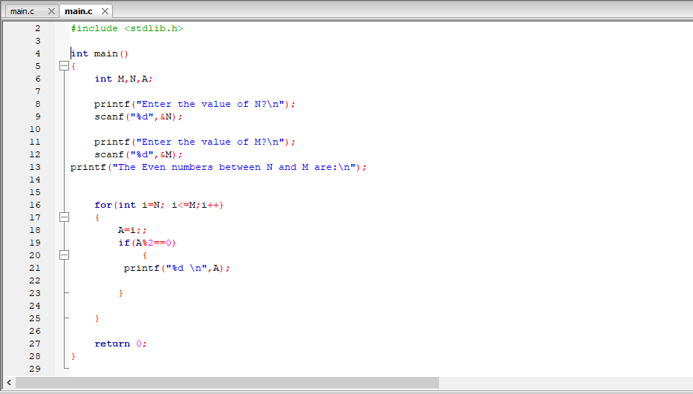

I tested my program with N as 1 and M as 10, the result is attached below,

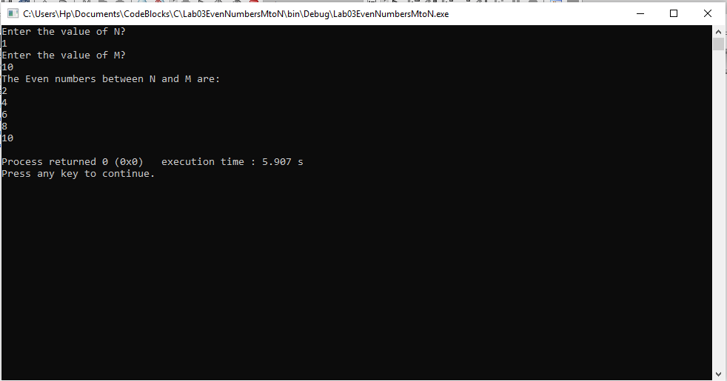

Hence the result shows that our program works.

_____________________________

**QUESTION NO:2**

Write C programs that output the following patterns exactly. Use a*s* ***few lines of code as possible***. You are free to use **integers**, **loops**, and **conditional statements** (e.g if/else)**.** No functions or arrays are allowed.

a. ******************* *****************

***************

*************

***********

*********

*********

***********

*************

***************

*****************

*******************

b.

*******************

*********

*****************

***********

***************

*************

*************

***************

***********

*****************

*********

*******************

Solution:

In this Question I used multiple print statemets to print the exact same pattern on the console, the code and result is attached below,

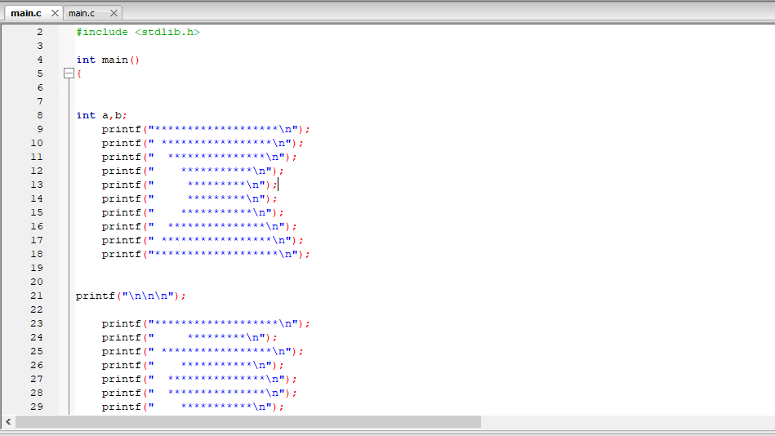

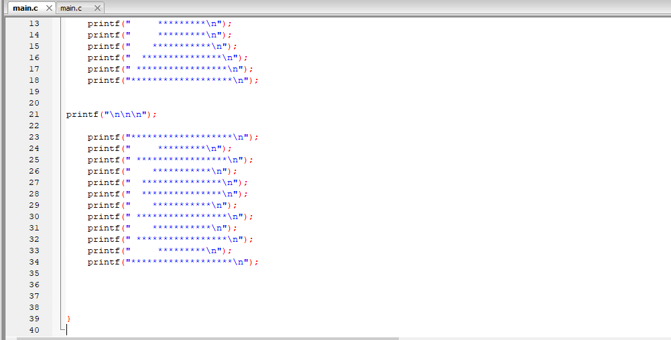

The Console Result is Attached below:

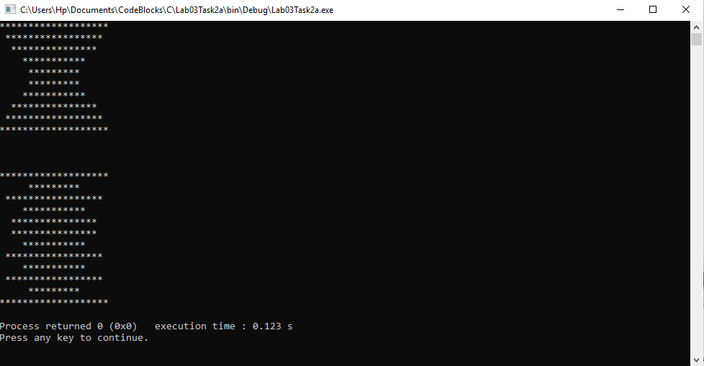

Hence the same patterns Verify the working of the Program.

________________________

POST LAB

Question:

a ******************

*****************

***************

*************

***********

*********

*********

***********

*************

***************

*****************

*******************

b.

*******************

*********

*****************

***********

***************

*************

*************

***************

***********

*****************

*********

*******************

Solution:

Part A

I am attaching my code below for this program, it was a very tough program to write, I used nested for loops for this program, codes and their results are attached below:

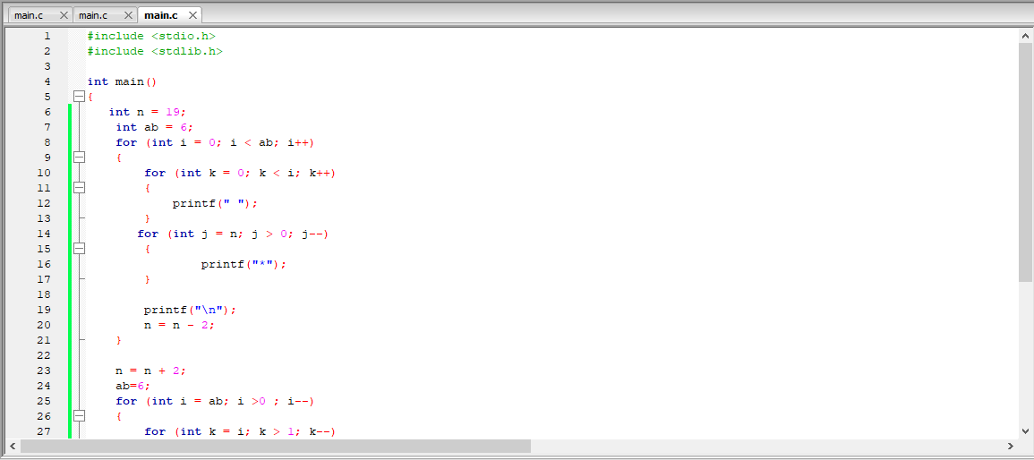

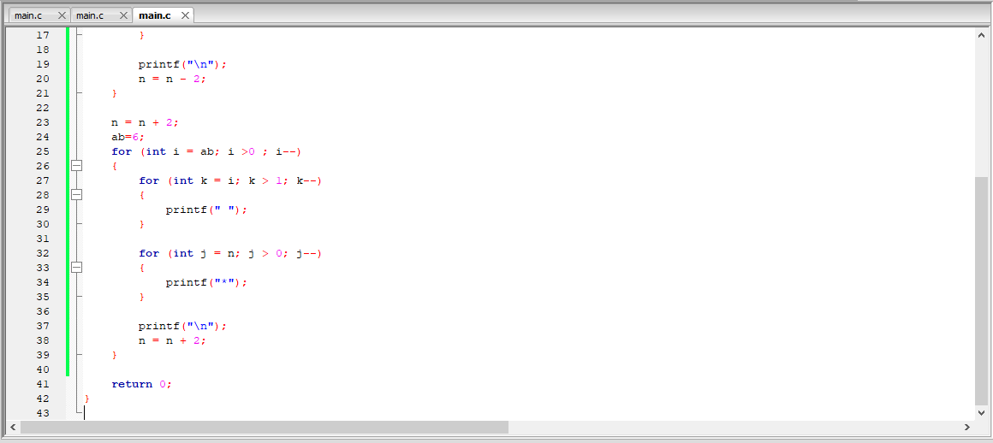

In the above code I have used one nested (for loop) for the upper portion of our pattern and another nested for loop for the lower portion of our pattern, the console result is displayed below,

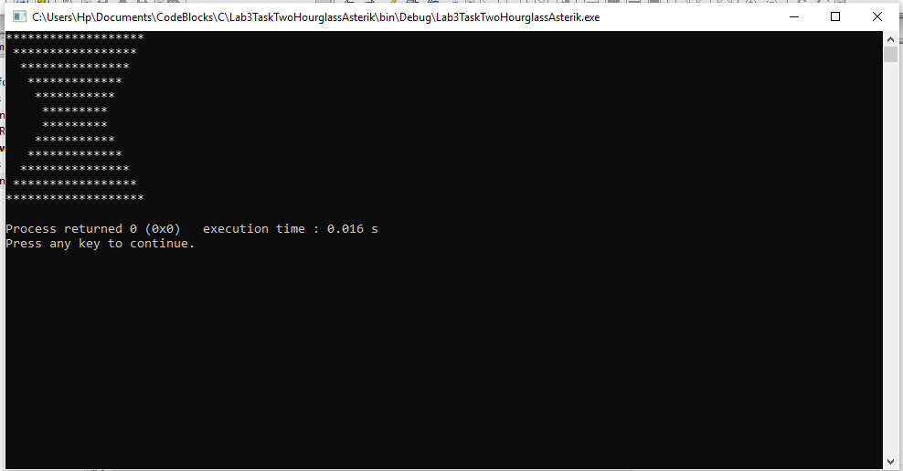

______THE END________

Hence, This Verify our pattern using For Loop.

___________________

**Part B**

The Code for Part B is attached below, this code consists of multiple for loops nested inside a for loop, writing a program for this code was very challenging, finally I am able to make the same pattern,

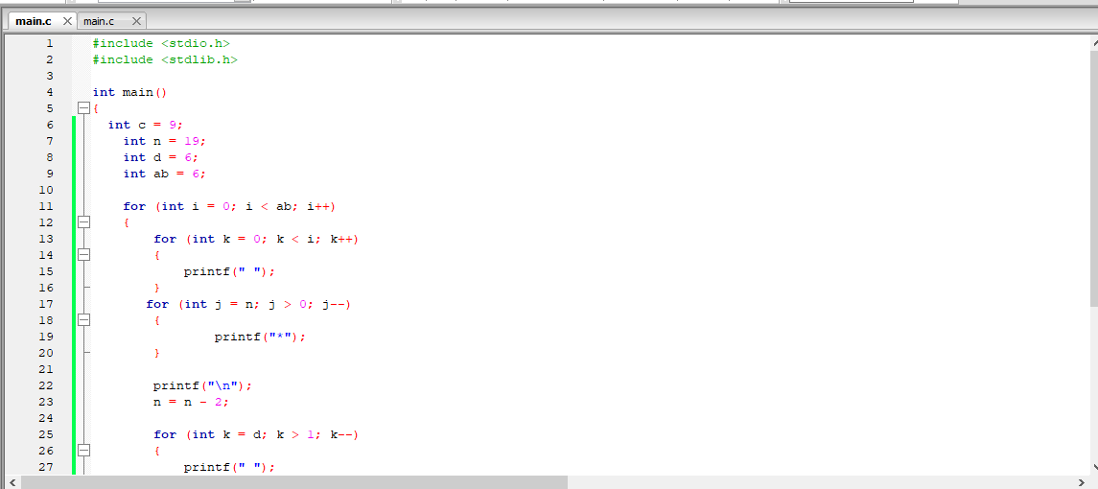CODE:

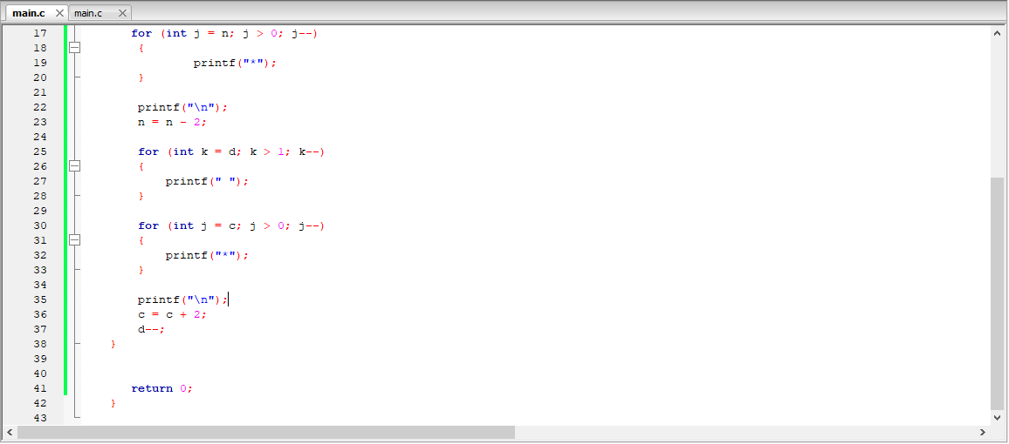

The output of this code is attached below,

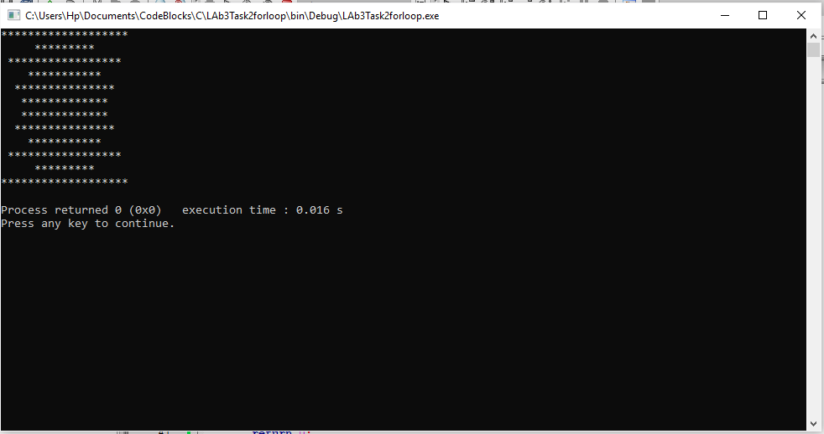

Hence, output verifies that our code using for loops is correct.

THE END